Use Cases of SmartHaven Mobile application:

**User Interactions:**

SmartHaven is a smart home-based mobile application that enables user to interact with devices at his home via internet and can access them from any where with internet and app from their mobile.

**Device Controls:**

They can also choose the way a device can be operated and in what range they can be operated.

They can turn on and turn off devices using app controls

They can add or remove devices.

**System Settings:**

They can change system setting via user login and admin access

Add or remove users

Mange users

**Class diagram:**

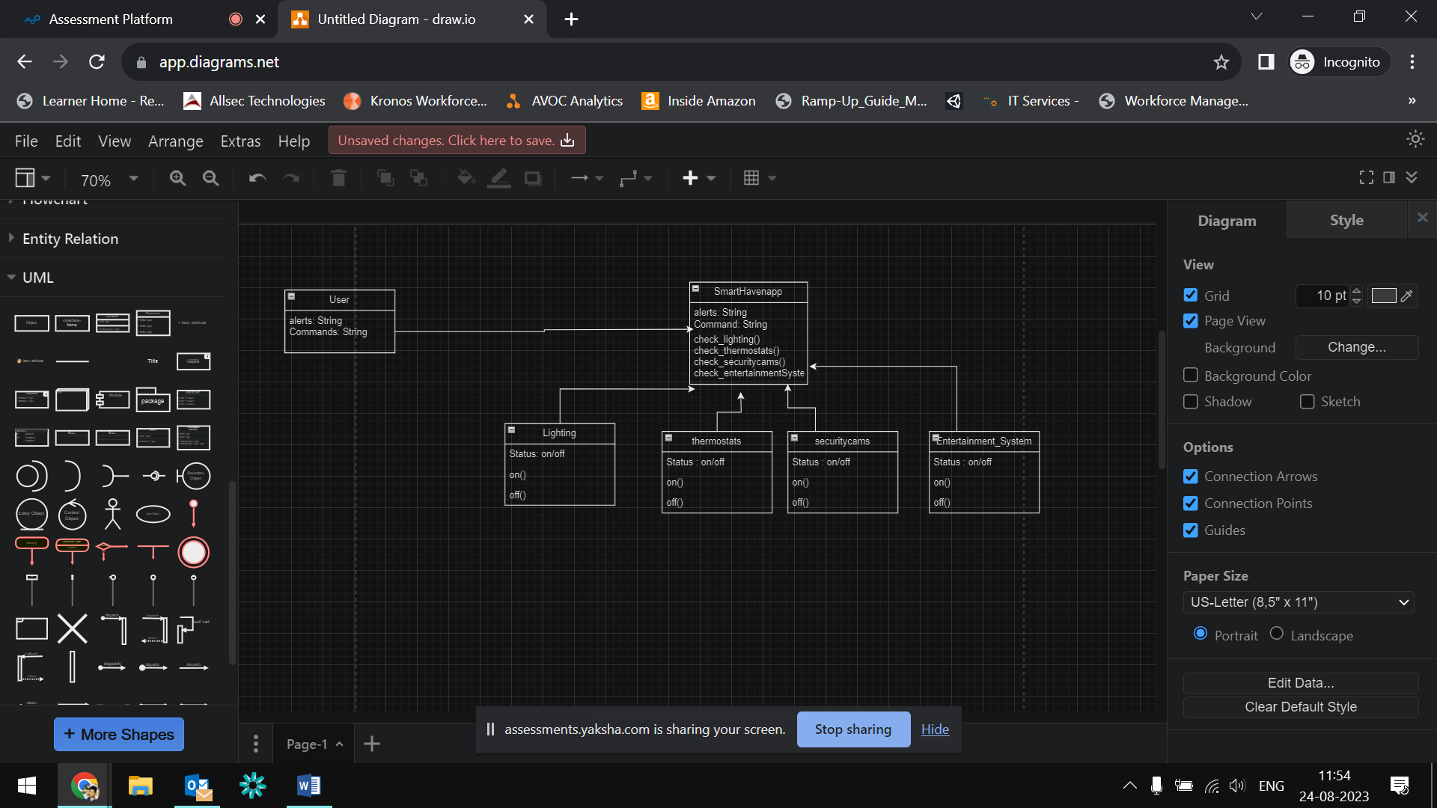

Created a class diagram with above basic operations of user and mobile app and 4 devices where user interacts with above devices via app with specific commands

**Activity diagram for setting up new device with smart haven:**

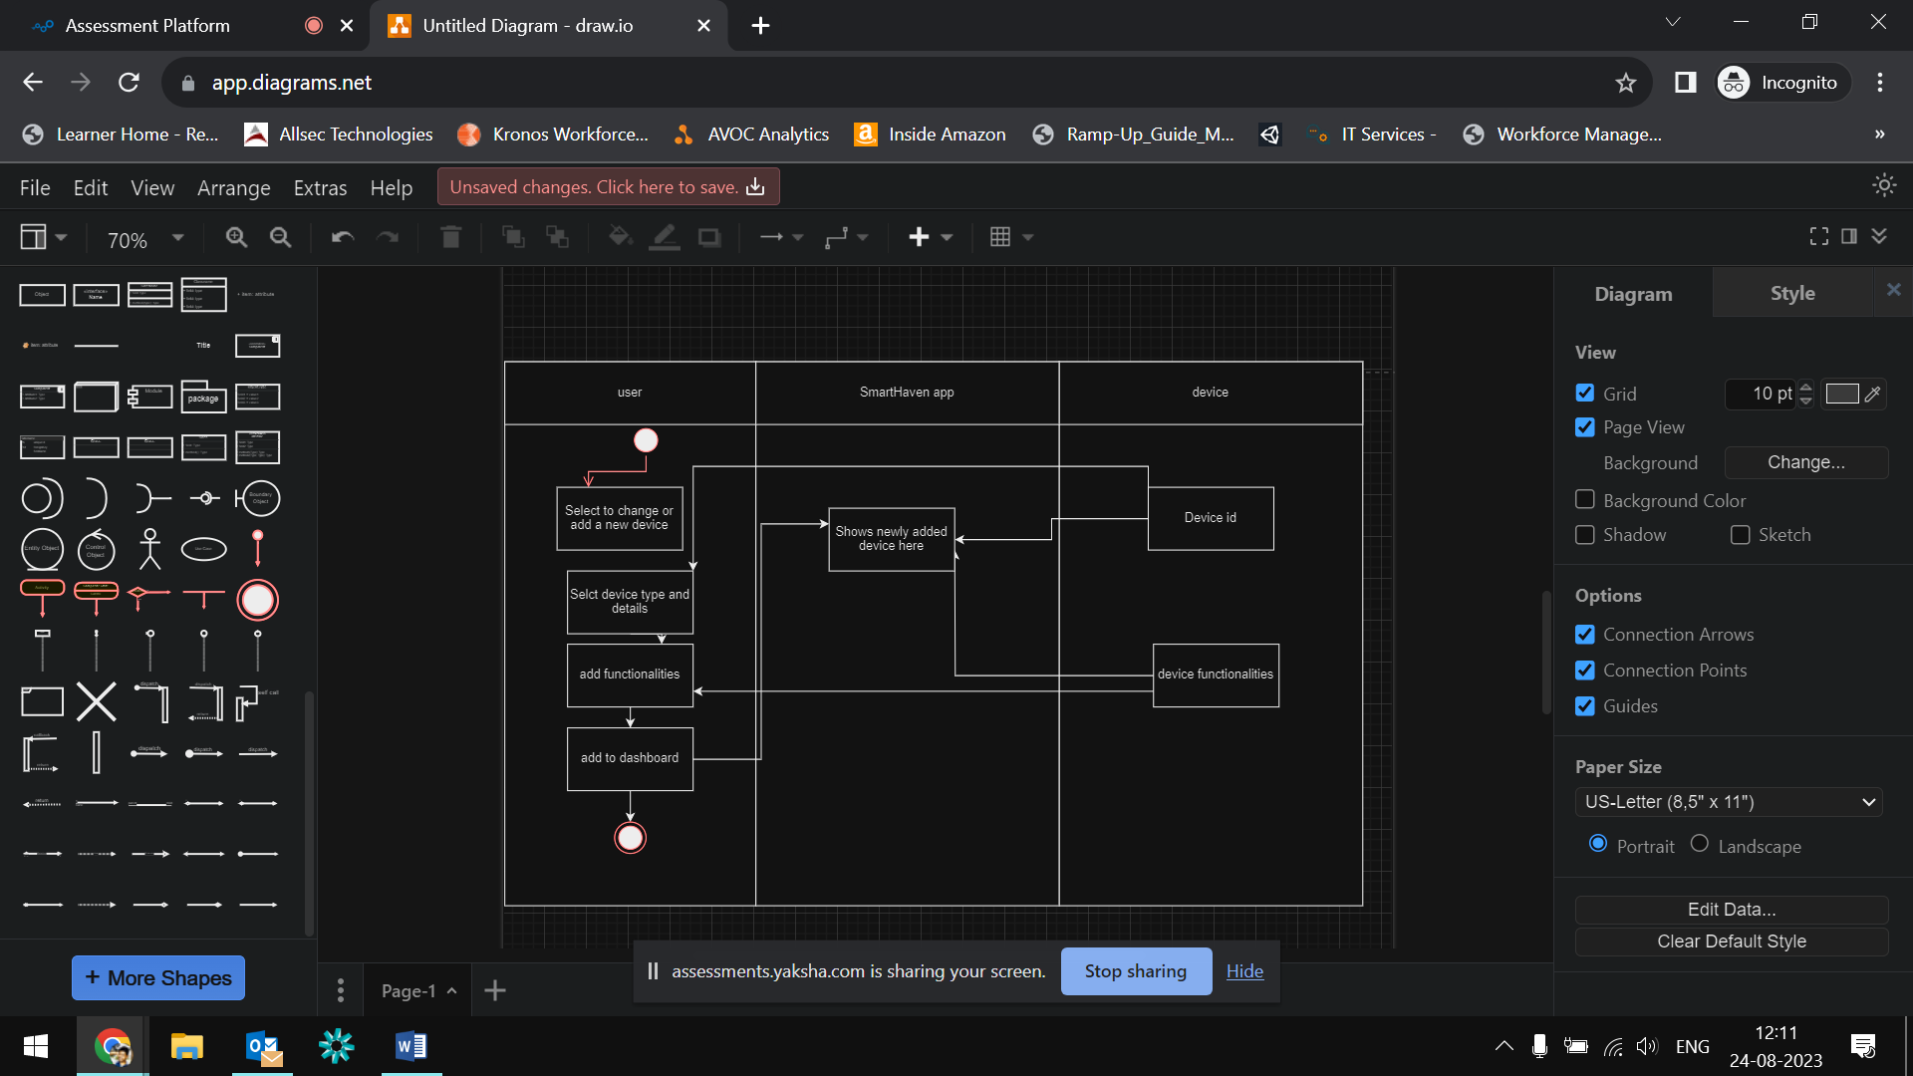

The above shows activity diagram for adding a device with device id and any of functionalities

**Thermostat and it’s transitions with state machine diagram:**

Thermostat is temperature controlling device , here in SMD we use this functionality as example of water heating

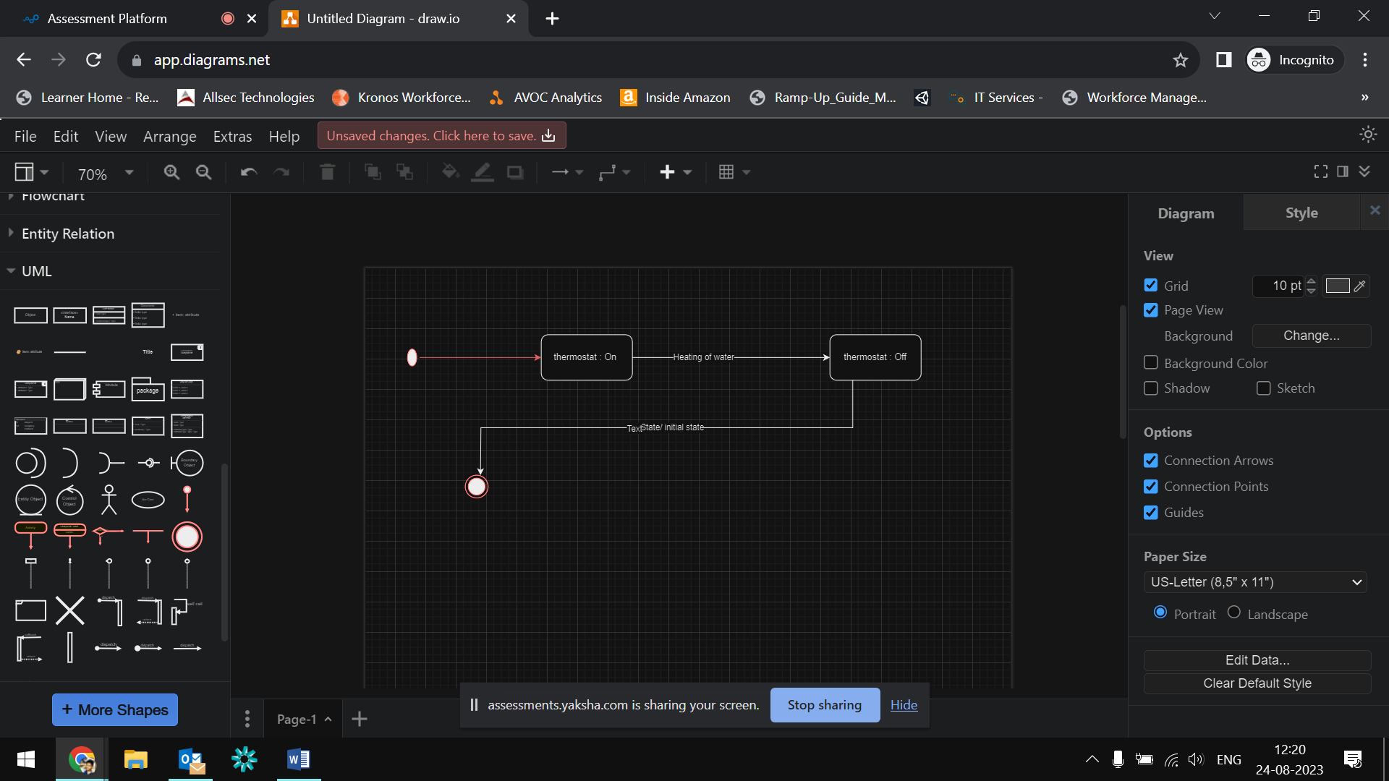

**Sequence diagram to turn on or off lights using smarthome**

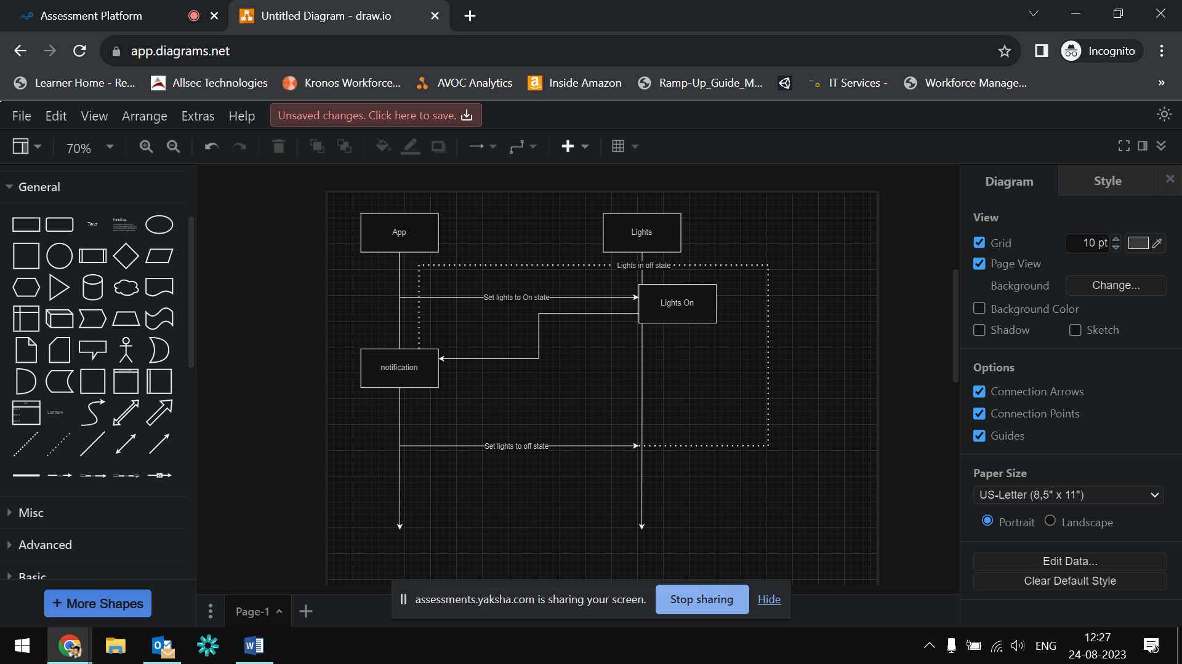

**Submitted by Shiva Kumar Gorasa**

**Login : shivagor@amazon.com**